Library Module – Static Library

1. Create 3 files as below. Let cal_utility.c, .h files be part of the library

· libapplication.c – will contain main() and will invoke functions in cal_utility.c

· cal_utility.c – will contain atleast 2 or more functions [ You may add definitions of the functions in this file ]

· cal_utility.h – will contain the extern declarations/prototypes of the functions in cal_utility.c

🡺cal_utility.h - This header file will declare the prototype of the utility functions.

🡺cal_utility.c - This source file will implement the functions declared in the header file.

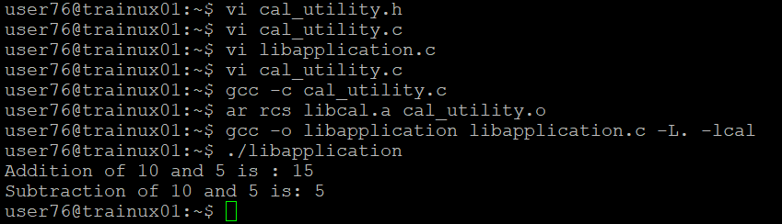

🡺 libapplication.c – This is the main application that will utilize the function from the utility library.

2. Refer the steps for static library based application and create a static library application using above set of files.

🡺 To create a static library from the cal_utility.c file, Compile the utility source file to object code using the command “gcc -c cal_utility.c. This will produce an object file named cal_utility.o.

🡺 To create the static library using the “ar” command, “ar rcs libcal.a cal_utility.o. This command creates a static library named libcal.a that contains cal_utility.o.

3. Execute the application created in step #2

🡺Compile the application with static library, by compile the libapplication.c source file and link it with the static library command “gcc -o libapplication libapplication.c -L. -lcal.



🡺Finally, run the compiled application “./libapplication”.

